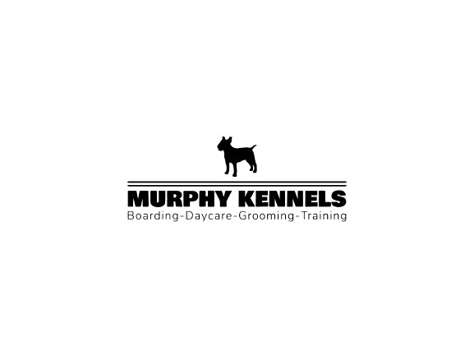
BOARDING CHECK-IN FORM

Pet Name ____________________ Pet Breed ___________________Boarding Dates: _____________________
Please Note: Pick-up and drop-off times on Saturdays and Sundays are 9:00am-11:00am ONLY
Owner Name ________________________________________ Phone #_________________________________
Emergency Contact ___________________________________ Phone #_________________________________
Feeding Instructions
Boarding Pet’s Food (Circle one) My own food / Kennel provided food (add’l charge $3.50-$4.50 by size)
Feed my pet (Circle one) Once a day (Specify AM or PM) / Twice a day / Three times a day / Free feed
How Much? _________________________________________________________Allergies? __________
If your pet has not eaten for 3 meals (or two full days) you authorize our staff to administer ‘Hospital diet EN canned food’ ($4.70 per can). After two cans we will contact you. Please initial authorization- _____________
Optional Add Ons
Would you like your pet to receive Bakery Treat Cookies ($2.50 each) (Circle one) Yes / No
How Often? Circle days: MON / TUES / WED / THURS / FRI / SAT / SUN
Would you like your pet to receive Licking Mats ($4 each) (Circle one) Yes / No
Preference: Peanut butter Pumpkin Plain Yogurt
How Often? Circle days: MON / TUES / WED / THURS / FRI / SAT / SUN
____________________________________________________________________________________
Dog Daycare = Monitored group play (There is no dog daycare on weekends!)
(Circle one) Yes / No Half Days - $18 /day / Full Days - $24 /day
Circle days: MON / TUES / WED / THURS / FRI

NEVER BEEN TO DAYCARE BEFORE? Would you like your dog evaluated for Dog Daycare ($25 for 4 hours)? (Circle One) Yes / No Please note: Not every pet is a good fit for group play and may not pass evaluation

Playtime = 20 Minutes Solo play with an employee Enrichment = Brain Games

Would you like your pet to have Individual Playtimes ($15/20 min or $42 for 3 sessions)?
(Circle One) Yes / No Circle days: MON / TUES / WED / THURS / FRI / SAT / SUN
Would you like your pet to have Enrichment Sessions ($10 each or $25 for 3 sessions)?
(Circle One) Yes / No Circle days: MON / TUES / WED / THURS / FRI / SAT / SUN

If your pet needs MEDICATION, please TURN SHEET OVER

Pet’s Medication Instructions

Pet’s Name Receiving Medication (If Multiple): _________________________________________________
Boarding Pet’s Medication ($4.00 per day): Will your pet require medication? Yes / No
Have they received today’s dose? (Circle one) Yes / No Which dose(s)? _____________________________
Medication ______________________ Instructions _________________________________________________
Medication ______________________ Instructions _________________________________________________
Medication ______________________ Instructions _________________________________________________
Medication ______________________ Instructions _________________________________________________
Medication ______________________ Instructions _________________________________________________

Will your pet require Diabetic Care ($6.00/day)? (Circle one) Yes / No ______# of units _____ times per day

______ initial Please note: We do our best to return boarding pets’ belongings, but occasionally items do get destroyed or go missing. As a result of this we cannot accept responsibility for leashes, bowls, blankets, toys, beds, etc. that may be damaged while your pet is boarding at our facility. You may list your pet’s belongings on the back of this sheet if you wish

